Exp.No.04
P.Sai Swetha
192324011

Crypt Arithmetic Problem

Aim:
To implement the Crypt Arithmetic Problem in Python and find the solution by assigning digits to letters such that the arithmetic equation is satisfied.
Algorithm:
Start.
Read the crypt arithmetic equation (e.g., SEND + MORE = MONEY).
Extract all unique letters from the equation.
Check if the number of unique letters is greater than 10.
- If Yes, print "No solution possible" and stop.
Generate all possible permutations of digits (0–9) for the unique letters.
Assign one unique digit to each letter.
Ensure that no leading letter of any word is assigned the digit 0.
Replace each letter in the words with its assigned digit.
Convert the words into their corresponding numerical values.
Check whether the arithmetic equation is satisfied.
- If Yes:
  - Display the digit assigned to each letter.
  - Display the numerical values of the words.
  - Stop the algorithm.
If the equation is not satisfied, generate the next permutation of digits.
Repeat Steps 6–11 until all possible assignments are checked.
If no valid assignment is found after checking all permutations, print "No solution exists."
Stop.
Program:
from itertools import permutations
word1 = input("Enter first word: ").upper()
word2 = input("Enter second word: ").upper()
result = input("Enter result word: ").upper()
letters = list(set(word1 + word2 + result))
if len(letters) > 10:
print("Too many unique letters!")
exit()
for p in permutations("0123456789", len(letters)):
d = dict(zip(letters, p))
if d[word1[0]] == '0' or d[word2[0]] == '0' or d[result[0]] == '0':
continue
n1 = int("".join(d[ch] for ch in word1))
n2 = int("".join(d[ch] for ch in word2))
n3 = int("".join(d[ch] for ch in result))
if n1 + n2 == n3:
print("Solution Found")
print(word1, "=", n1)
print(word2, "=", n2)
print(result, "=", n3)
break
else:
print("No solution found")

Input:
Enter first word: SEND
Enter second word: MORE
Enter result word: MONEY

Output:
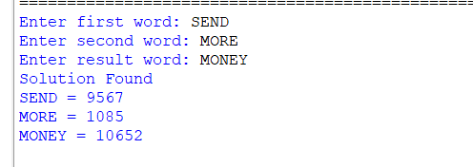

Result:
Thus, the Crypt Arithmetic Problem was implemented successfully in Python, and a valid assignment of digits to letters was obtained such that the given arithmetic equation was satisfied.

